
K1 CSE3023 PEMBANGUNAN APLIKASI BERASASKAN WEB
SEM 4
LAB REPORT 7

PREPARED FOR:
ASSOC. PROF. TS. DR. WAN NURAL JWAHIR
LAB ASSISTANT:
MADAM WAN FATIN FATIHAH

PREPARED BY:
NUR ADLYNN SYAKIRAH BINTI NOR KHAIRUL ANUAR
NO. MATRIC:
S76245

LAB EXERCISE 7
1. Login and register
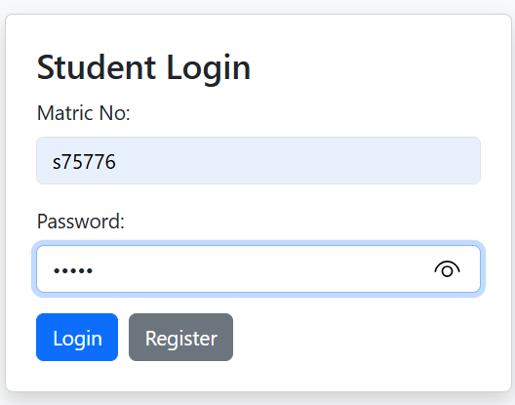
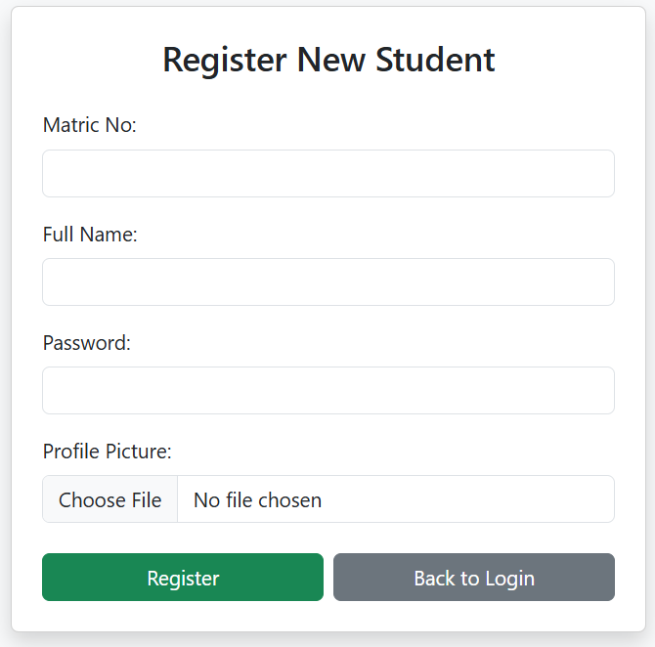

2. Dashboard
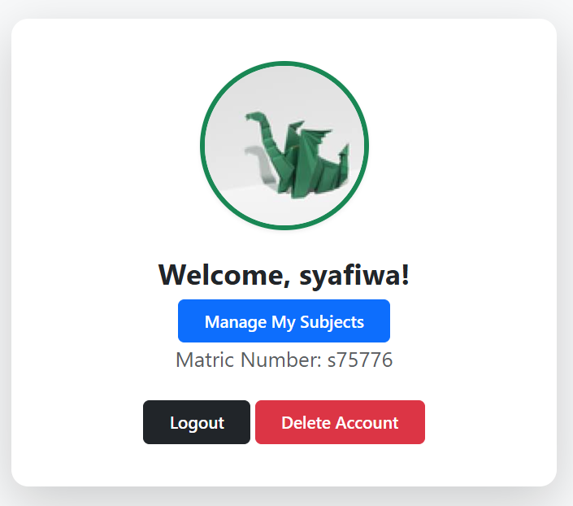

3. Create
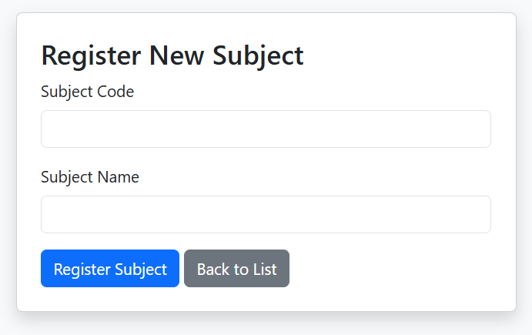
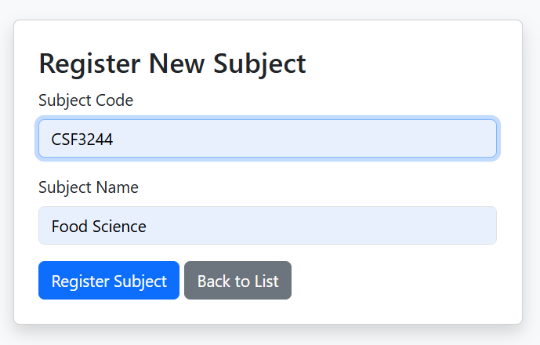
4. Read (view)
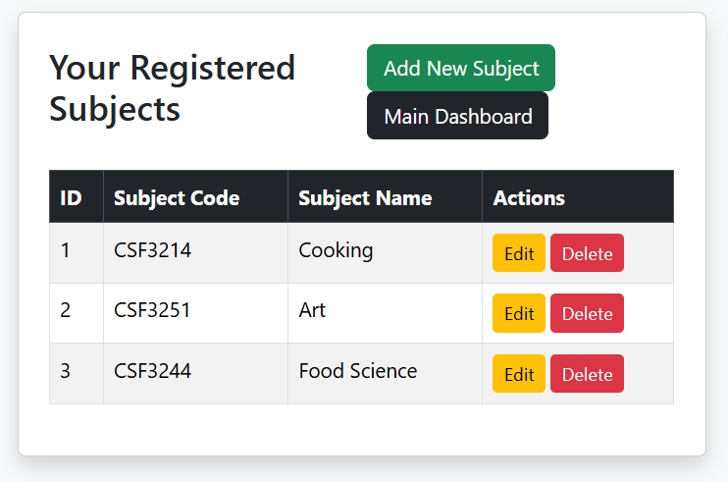

5. Update
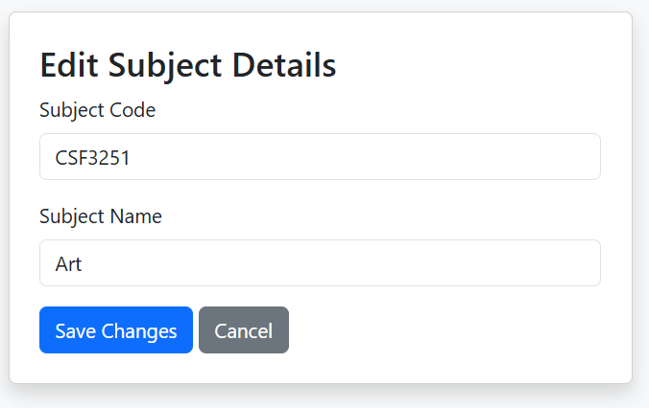
6. Delete
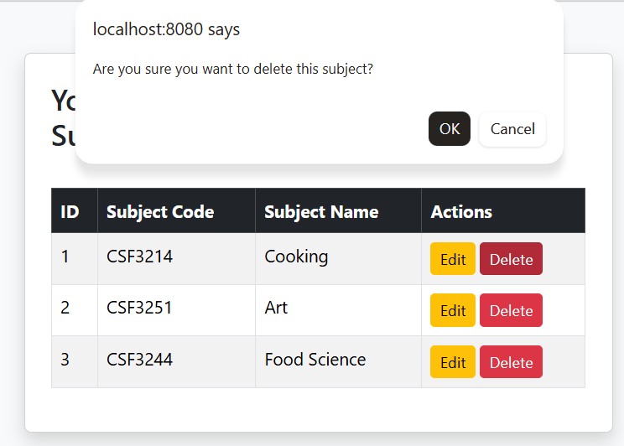
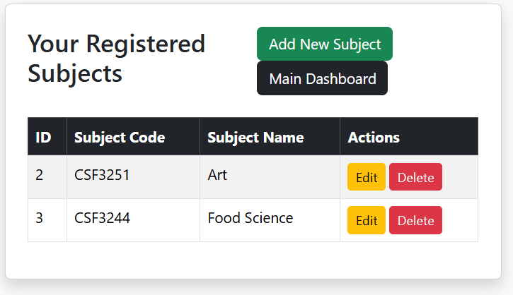
7. Project Structure
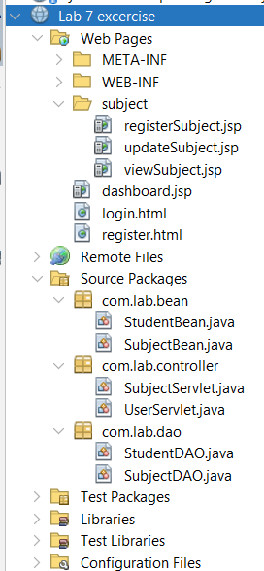

CODING
- registerSubject.jsp
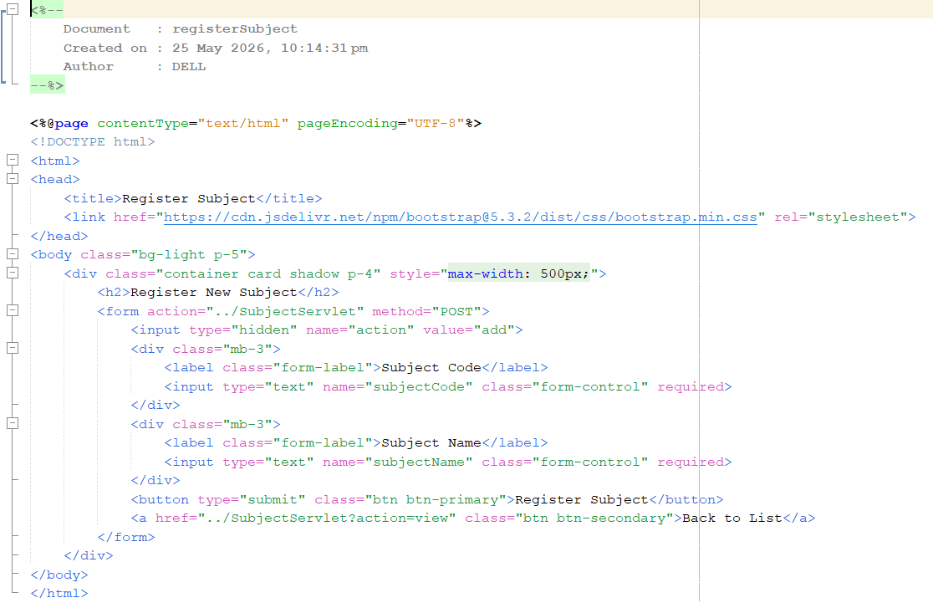
- updatesubject.jsp
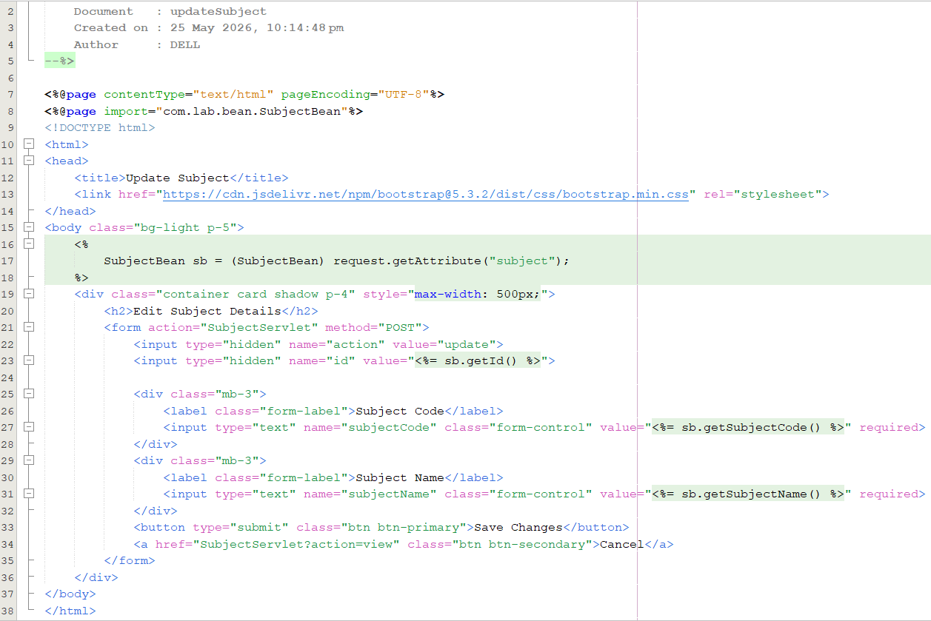
- viewSubject.jsp
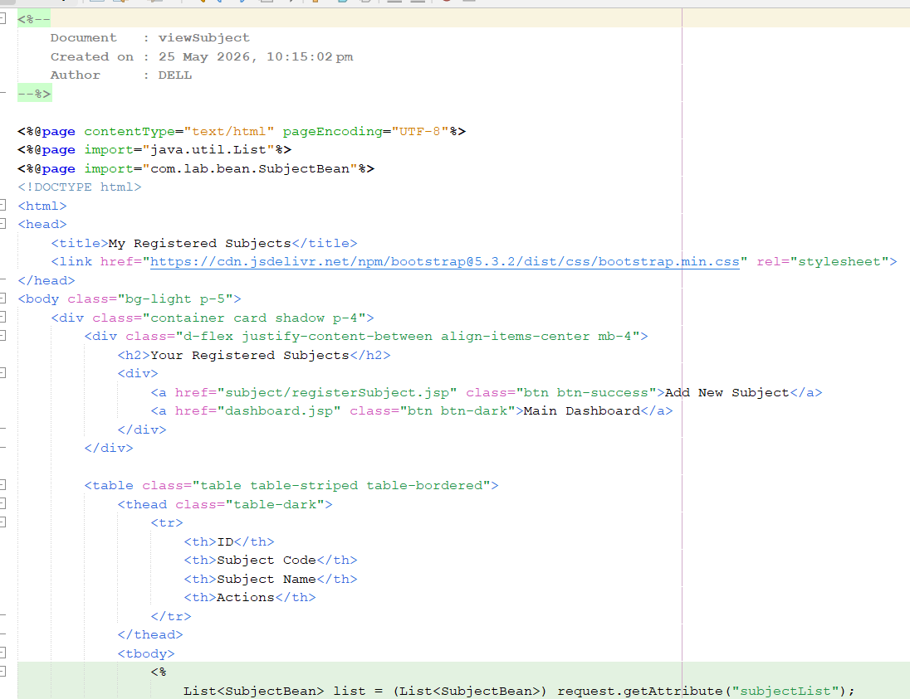
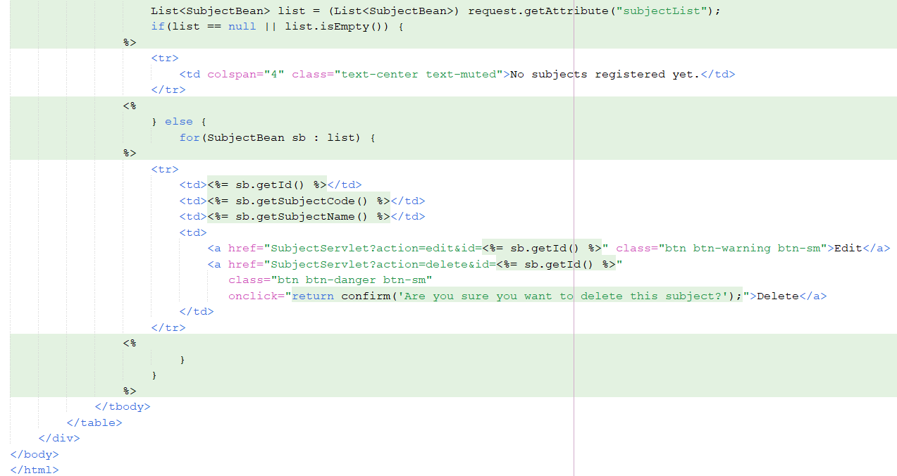

- dashboard.jsp
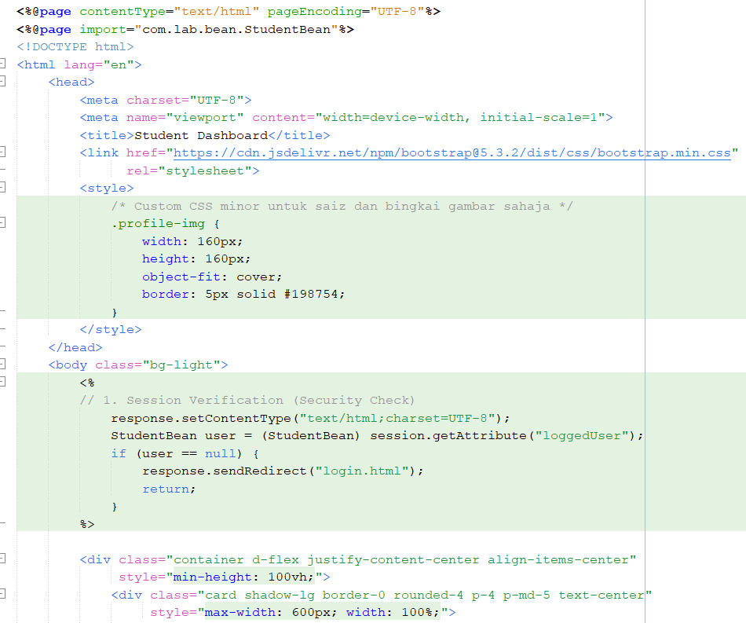
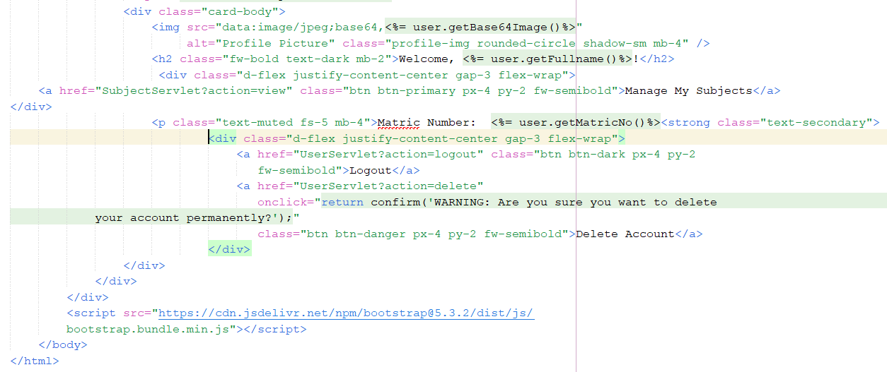

- login.html
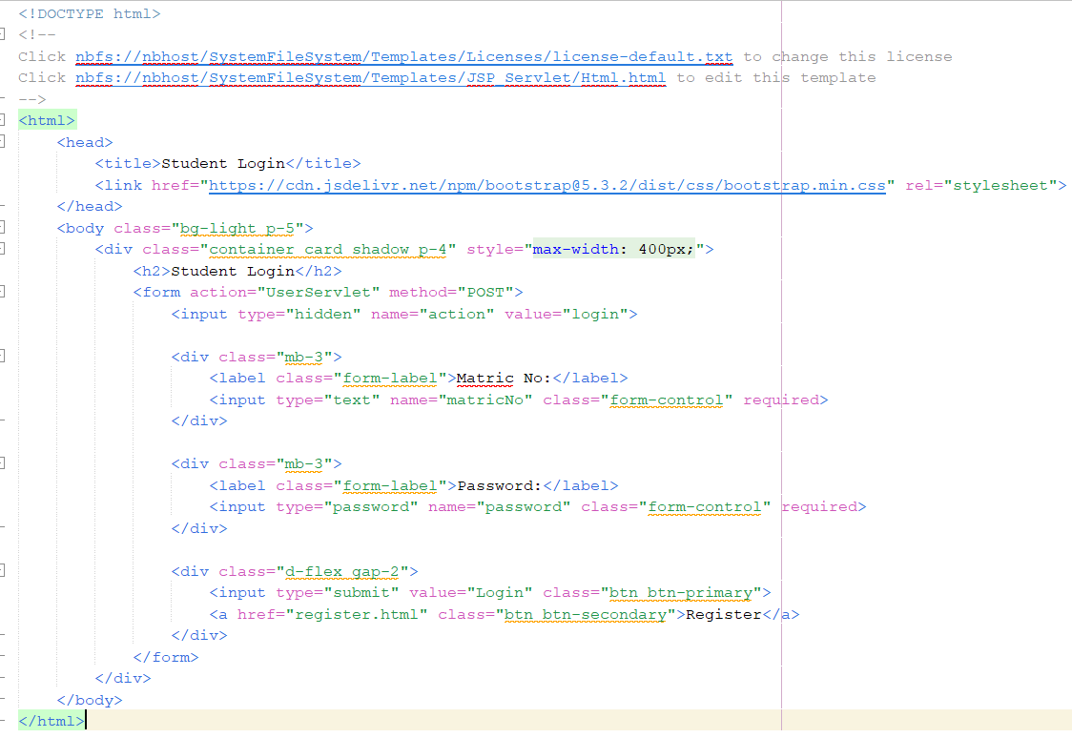
- register.html
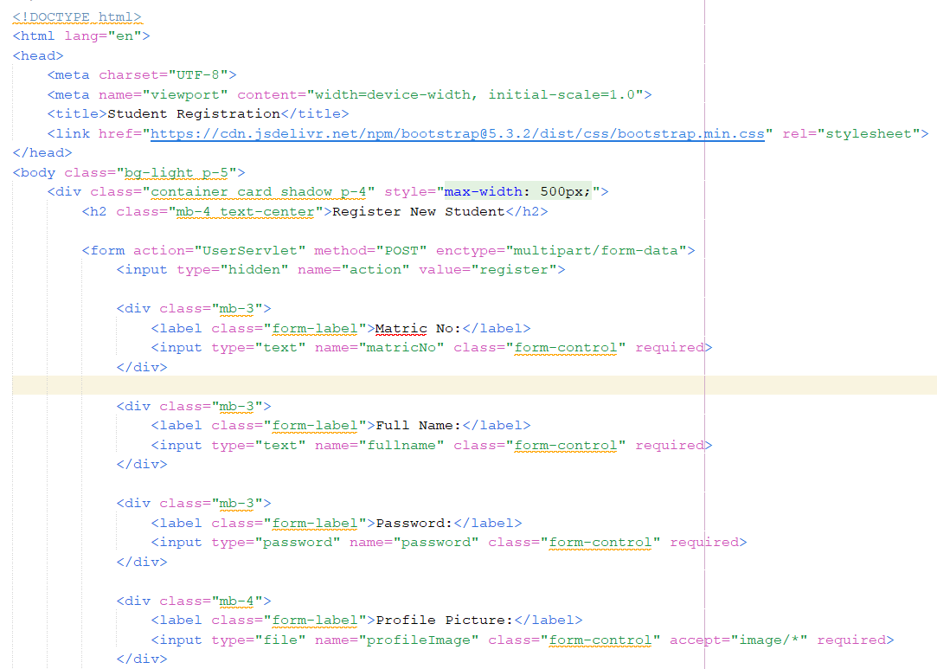
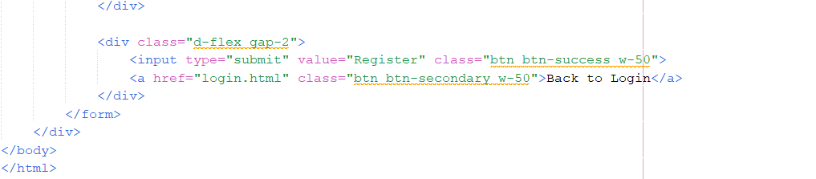
- StudentBean.java
/*
* Click nbfs://nbhost/SystemFileSystem/Templates/Licenses/license-default.txt to change this license
* Click nbfs://nbhost/SystemFileSystem/Templates/Classes/Class.java to edit this template
*/
package com.lab.bean;

public class StudentBean implements java.io.Serializable {

private String matricNo;
private String fullname;
private String password;
private String base64Image;

public StudentBean() {
}

public String getMatricNo() {
return matricNo;
}

public void setMatricNo(String matricNo) {
this.matricNo = matricNo;
}

public String getFullname() {
return fullname;
}

public void setFullname(String fullname) {
this.fullname = fullname;
}

public String getPassword() {
return password;
}

public void setPassword(String password) {
this.password = password;
}

public String getBase64Image() {
return base64Image;
}

public void setBase64Image(String base64Image) {
this.base64Image = base64Image;
}
}

- SubjectBean.java
package com.lab.bean;

public class SubjectBean {

private int id;
private String matricNo;
private String subjectCode;
private String subjectName;

public SubjectBean() {
}

public int getId() {
return id;
}

public void setId(int id) {
this.id = id;
}

public String getMatricNo() {
return matricNo;
}

public void setMatricNo(String matricNo) {
this.matricNo = matricNo;
}

public String getSubjectCode() {
return subjectCode;
}

public void setSubjectCode(String subjectCode) {
this.subjectCode = subjectCode;
}

public String getSubjectName() {
return subjectName;
}

public void setSubjectName(String subjectName) {
this.subjectName = subjectName;
}
}

- SubjectServlet.java
package com.lab.controller;

import com.lab.bean.StudentBean;
import com.lab.bean.SubjectBean;
import com.lab.dao.SubjectDAO;
import java.io.IOException;
import java.util.List;
import javax.servlet.ServletException;
import javax.servlet.http.HttpServlet;
import javax.servlet.http.HttpServletRequest;
import javax.servlet.http.HttpServletResponse;
import javax.servlet.http.HttpSession;

public class SubjectServlet extends HttpServlet {
private SubjectDAO subjectDAO = new SubjectDAO();

protected void doGet(HttpServletRequest request, HttpServletResponse response) throws ServletException, IOException {
HttpSession session = request.getSession(false);
// Security check: Check if student session exists
if (session == null || session.getAttribute("loggedUser") == null) {
response.sendRedirect("login.html");
return;
}

String action = request.getParameter("action");
StudentBean loggedUser = (StudentBean) session.getAttribute("loggedUser");
String matricNo = loggedUser.getMatricNo();

if ("view".equals(action) || action == null) {
List<SubjectBean> subjectList = subjectDAO.getSubjectsByStudent(matricNo);
request.setAttribute("subjectList", subjectList);
request.getRequestDispatcher("subject/viewSubject.jsp").forward(request, response);

} else if ("delete".equals(action)) {
int id = Integer.parseInt(request.getParameter("id"));
subjectDAO.deleteSubject(id);
response.sendRedirect("SubjectServlet?action=view");

} else if ("edit".equals(action)) {
int id = Integer.parseInt(request.getParameter("id"));
SubjectBean sub = subjectDAO.getSubjectById(id);
request.setAttribute("subject", sub);
request.getRequestDispatcher("subject/updateSubject.jsp").forward(request, response);
}
}

protected void doPost(HttpServletRequest request, HttpServletResponse response) throws ServletException, IOException {
HttpSession session = request.getSession(false);
if (session == null || session.getAttribute("loggedUser") == null) {
response.sendRedirect("login.html");
return;
}

String action = request.getParameter("action");
StudentBean loggedUser = (StudentBean) session.getAttribute("loggedUser");

if ("add".equals(action)) {
SubjectBean sb = new SubjectBean();
sb.setMatricNo(loggedUser.getMatricNo());
sb.setSubjectCode(request.getParameter("subjectCode"));
sb.setSubjectName(request.getParameter("subjectName"));

subjectDAO.addSubject(sb);
response.sendRedirect("SubjectServlet?action=view");

} else if ("update".equals(action)) {
SubjectBean sb = new SubjectBean();
sb.setId(Integer.parseInt(request.getParameter("id")));
sb.setSubjectCode(request.getParameter("subjectCode"));
sb.setSubjectName(request.getParameter("subjectName"));

subjectDAO.updateSubject(sb);
response.sendRedirect("SubjectServlet?action=view");
}
}
}

- UserServlet.java
package com.lab.controller;

/*
* Click nbfs://nbhost/SystemFileSystem/Templates/Licenses/license-default.txt to change this license
* Click nbfs://nbhost/SystemFileSystem/Templates/JSP_Servlet/Servlet.java to edit this template
*/
import com.lab.bean.StudentBean;
import com.lab.dao.StudentDAO;
import java.io.IOException;
import java.io.InputStream;
import java.io.PrintWriter;
import javax.servlet.ServletException;
import javax.servlet.annotation.MultipartConfig;
import javax.servlet.http.HttpServlet;
import javax.servlet.http.HttpServletRequest;
import javax.servlet.http.HttpServletResponse;
import javax.servlet.http.HttpSession;
import javax.servlet.http.Part;

@MultipartConfig(maxFileSize = 16177215) // max 16 MB required for image upload
public class UserServlet extends HttpServlet {

private StudentDAO studentDAO = new StudentDAO();

/**
* Processes requests for both HTTP <code>GET</code> and <code>POST</code>
* methods.
*
* @param request servlet request
* @param response servlet response
* @throws ServletException if a servlet-specific error occurs
* @throws IOException if an I/O error occurs
*/
protected void processRequest(HttpServletRequest request, HttpServletResponse response)
throws ServletException, IOException {
response.setContentType("text/html;charset=UTF-8");
try (PrintWriter out = response.getWriter()) {
/* TODO output your page here. You may use following sample code. */
out.println("<!DOCTYPE html>");
out.println("<html>");
out.println("<head>");
out.println("<title>Servlet UserServlet</title>");
out.println("</head>");
out.println("<body>");
out.println("<h1>Servlet UserServlet at " + request.getContextPath() + "</h1>");
out.println("</body>");
out.println("</html>");
}
}

// <editor-fold defaultstate="collapsed" desc="HttpServlet methods. Click on the + sign on the left to edit the code.">
/**
* Handles the HTTP <code>GET</code> method.
*
* @param request servlet request
* @param response servlet response
* @throws ServletException if a servlet-specific error occurs
* @throws IOException if an I/O error occurs
*/
@Override
protected void doPost(HttpServletRequest request, HttpServletResponse response)
throws ServletException, IOException {
response.setContentType("text/html;charset=UTF-8");
String action = request.getParameter("action");
if ("register".equals(action)) {
// --- 1. HANDLE REGISTRATION ---
StudentBean newStudent = new StudentBean();
newStudent.setMatricNo(request.getParameter("matricNo"));
newStudent.setFullname(request.getParameter("fullname"));
newStudent.setPassword(request.getParameter("password"));
InputStream inputStream = null;
Part filePart = request.getPart("profileImage");
if (filePart != null && filePart.getSize() > 0) {
inputStream = filePart.getInputStream();
}
boolean isSuccess = studentDAO.registerStudent(newStudent, inputStream);
if (isSuccess) {
response.getWriter().println("Registration Successful!<a href='login.html'>Login here</a>");
} else {
response.getWriter().println("Registration Failed!");
}
} else if ("login".equals(action)) {
// --- 2. HANDLE LOGIN ---
String matric = request.getParameter("matricNo");
String pass = request.getParameter("password");
StudentBean student = studentDAO.loginStudent(matric, pass);
if (student != null) {
HttpSession session = request.getSession();
session.setAttribute("loggedUser", student);
response.sendRedirect("dashboard.jsp");
} else {
response.getWriter().println("Invalid Credentials!<a href='login.html'>Try Again</a>");
}
}
}

@Override
protected void doGet(HttpServletRequest request, HttpServletResponse response)
throws ServletException, IOException {
String action = request.getParameter("action");
HttpSession session = request.getSession(false);
if ("logout".equals(action)) {
// --- 3. HANDLE LOGOUT ---
if (session != null) {
session.invalidate(); // Destroy session
}
response.sendRedirect("login.html");
} else if ("delete".equals(action)) {
// --- 4. HANDLE DELETE ACCOUNT ---
if (session != null && session.getAttribute("loggedUser") != null) {
StudentBean user = (StudentBean) session.getAttribute("loggedUser");
studentDAO.deleteStudent(user.getMatricNo());
session.invalidate(); // Destroy session after account deletion
}
response.sendRedirect("register.html");
}
}

@Override
public String getServletInfo() {
return "Short description";
}

}

- StudentDAO.java
/*
* Click nbfs://nbhost/SystemFileSystem/Templates/Licenses/license-default.txt to change this license
* Click nbfs://nbhost/SystemFileSystem/Templates/Classes/Class.java to edit this template
*/
package com.lab.dao;

import com.lab.bean.StudentBean;
import java.io.ByteArrayOutputStream;
import java.io.InputStream;
import java.sql.Blob;
import java.sql.Connection;
import java.sql.DriverManager;
import java.sql.PreparedStatement;
import java.sql.ResultSet;
import java.util.Base64;

public class StudentDAO {

private Connection getConnection() throws Exception {
Class.forName("com.mysql.cj.jdbc.Driver");
return DriverManager.getConnection("jdbc:mysql://localhost:3307/lab7_db",
"root", "");
}
// --- REGISTER LOGIC ---

public boolean registerStudent(StudentBean student, InputStream imageStream) {
try (Connection conn = getConnection()) {
String sql ="INSERT INTO students (matric_no, password, fullname, profile_image) VALUES(?, ?, ?, ?)";
PreparedStatement pstmt = conn.prepareStatement(sql);
pstmt.setString(1, student.getMatricNo());
pstmt.setString(2, student.getPassword());
pstmt.setString(3, student.getFullname());
pstmt.setBlob(4, imageStream); // Set BLOB data
return pstmt.executeUpdate() > 0;
} catch (Exception e) {
e.printStackTrace();
return false;
}
}
// --- LOGIN LOGIC ---

public StudentBean loginStudent(String matricNo, String password) {
StudentBean student = null;
try (Connection conn = getConnection()) {
String sql = "SELECT * FROM students WHERE matric_no = ? AND password = ?";
PreparedStatement pstmt = conn.prepareStatement(sql);
pstmt.setString(1, matricNo);
pstmt.setString(2, password);
ResultSet rs = pstmt.executeQuery();
if (rs.next()) {
student = new StudentBean();
student.setMatricNo(rs.getString("matric_no"));
student.setFullname(rs.getString("fullname"));
Blob blob = rs.getBlob("profile_image");
if (blob != null) {
InputStream inputStream = blob.getBinaryStream();
ByteArrayOutputStream outputStream = new ByteArrayOutputStream();
byte[] buffer = new byte[4096];
int bytesRead = -1;
while ((bytesRead = inputStream.read(buffer)) != -1) {
outputStream.write(buffer, 0, bytesRead);
}
byte[] imageBytes = outputStream.toByteArray();
student.setBase64Image(Base64.getEncoder().encodeToString(imageBytes));
}
}
} catch (Exception e) {
e.printStackTrace();
}
return student;
}
// --- DELETE LOGIC ---

public boolean deleteStudent(String matricNo) {
try (Connection conn = getConnection()) {
String sql = "DELETE FROM students WHERE matric_no = ?";
PreparedStatement pstmt = conn.prepareStatement(sql);
pstmt.setString(1, matricNo);
return pstmt.executeUpdate() > 0;
} catch (Exception e) {
e.printStackTrace();
return false;
}
}
}

- SubjectDAO.java
package com.lab.dao;

import com.lab.bean.SubjectBean;
import java.sql.*;
import java.util.ArrayList;
import java.util.List;

public class SubjectDAO {
private Connection getConnection() throws Exception {
Class.forName("com.mysql.cj.jdbc.Driver");
return DriverManager.getConnection("jdbc:mysql://localhost:3307/lab7_db","root", "");
}

// CREATE
public boolean addSubject(SubjectBean subject) {
String sql = "INSERT INTO registered_subjects (matric_no, subject_code, subject_name) VALUES (?, ?, ?)";
try (Connection conn = getConnection(); PreparedStatement pstmt = conn.prepareStatement(sql)) {
pstmt.setString(1, subject.getMatricNo());
pstmt.setString(2, subject.getSubjectCode());
pstmt.setString(3, subject.getSubjectName());
return pstmt.executeUpdate() > 0;
} catch (Exception e) {
e.printStackTrace();
return false;
}
}

// READ
public List<SubjectBean> getSubjectsByStudent(String matricNo) {
List<SubjectBean> list = new ArrayList<>();
String sql = "SELECT * FROM registered_subjects WHERE matric_no = ?";
try (Connection conn = getConnection(); PreparedStatement pstmt = conn.prepareStatement(sql)) {
pstmt.setString(1, matricNo);
try (ResultSet rs = pstmt.executeQuery()) {
while (rs.next()) {
SubjectBean sub = new SubjectBean();
sub.setId(rs.getInt("id"));
sub.setMatricNo(rs.getString("matric_no"));
sub.setSubjectCode(rs.getString("subject_code"));
sub.setSubjectName(rs.getString("subject_name"));
list.add(sub);
}
}
} catch (Exception e) {
e.printStackTrace();
}
return list;
}

// (For editing)
public SubjectBean getSubjectById(int id) {
String sql = "SELECT * FROM registered_subjects WHERE id = ?";
try (Connection conn = getConnection(); PreparedStatement pstmt = conn.prepareStatement(sql)) {
pstmt.setInt(1, id);
try (ResultSet rs = pstmt.executeQuery()) {
if (rs.next()) {
SubjectBean sub = new SubjectBean();
sub.setId(rs.getInt("id"));
sub.setMatricNo(rs.getString("matric_no"));
sub.setSubjectCode(rs.getString("subject_code"));
sub.setSubjectName(rs.getString("subject_name"));
return sub;
}
}
} catch (Exception e) {
e.printStackTrace();
}
return null;
}

// UPDATE
public boolean updateSubject(SubjectBean subject) {
String sql = "UPDATE registered_subjects SET subject_code = ?, subject_name = ? WHERE id = ?";
try (Connection conn = getConnection(); PreparedStatement pstmt = conn.prepareStatement(sql)) {
pstmt.setString(1, subject.getSubjectCode());
pstmt.setString(2, subject.getSubjectName());
pstmt.setInt(3, subject.getId());
return pstmt.executeUpdate() > 0;
} catch (Exception e) {
e.printStackTrace();
return false;
}
}

// DELETE
public boolean deleteSubject(int id) {
String sql = "DELETE FROM registered_subjects WHERE id = ?";
try (Connection conn = getConnection(); PreparedStatement pstmt = conn.prepareStatement(sql)) {
pstmt.setInt(1, id);
return pstmt.executeUpdate() > 0;
} catch (Exception e) {
e.printStackTrace();
return false;
}
}
}
13. Database
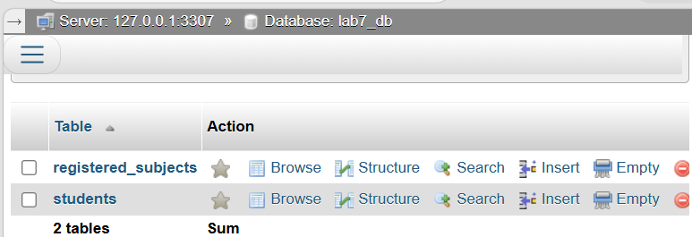
14. Table registered_subjects
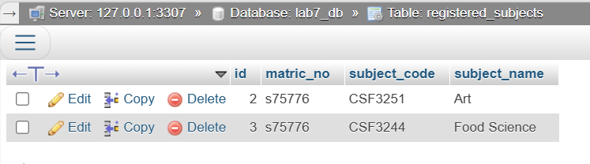
15. Table students
